
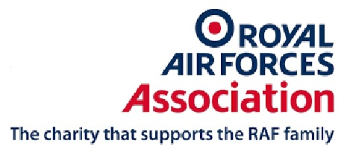

Royal Air Force Association
Torquay Branch
would like to invite you to
The Battle of Britain Service
at
St Lukes Church
St Lukes Road
Torquay
TQ2 5NX
Sunday 17th September 2017
at 11.00am
Followed by lunch at
Raffles Club
7 Scarborough Road
Torquay
TQ2 5UJ


